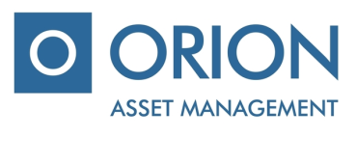

Management company uždaroji akcinė bendrovė “Orion Asset management”

Legal entity code 111707985, registered office address at Antano Tumėno St. 4,
“Vakarų” entrance, 12th floor, Vilnius, the Republic of Lithuania
Phone.: +370 5 203 2699, e-mail.: oam@orion.lt

Investment company with variable capital “OMX Baltic Benchmark Fund” (hereinafter – “the Company”)
the ordinary general meeting of the shareholders of the 30th of April, 2020

GENERAL VOTING BALLOT

Shareholder’s name, surname ………………..…………………....................……...................................................................

Shareholder’s identification number………………………………………................................................................................

Number of shares of the Company………......................................................................................................................................

AGENDA OF THE MEETING | - Regarding assent to of the Annual Report of investment company with variable capital "OMX Baltic Benchmark Fund” for the year 2019.  - Regarding approval of the audited Annual Financial Statements of investment company with variable capital "OMX Baltic Benchmark Fund” for the year 2019.

VOTING:

AGENDA ITEMS | DECISION | Fill in  „FOR“/ „AGAINST“
- Regarding assent to of the Annual Report of investment company with variable capital "OMX Baltic Benchmark Fund” for the year 2019. | - To give the assent to the annual report of investment company with variable capital "OMX Baltic Benchmark Fund” for the year 2019.
- Regarding approval of the audited Annual Financial Statements of investment company with variable capital "OMX Baltic Benchmark Fund” for the year 2019. | - To approve the audited Annual Financial Statements of investment company with variable capital "OMX Baltic Benchmark Fund” for the year 2019.

________________________________________________
(Shareholder’s (representative’s) name, surname, signature)

