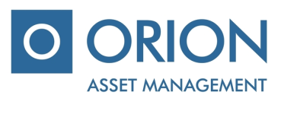

UAB “Orion Asset management”

Private limited company, registered office A. Tumėno g. 4, B corps, 7 floor, Vilnius, mob.: + 370 5 231 3833, faks.: +370 5 231 3840, email.: oam@orion.lt

IKKB “OMX Baltic Benchmark Fund” (hereinafter – “the Company”), voting ballot of the additional shareholders extraordinary meeting, which will take place on 24 July, 2017

Shareholders name, surname ………………..…………………....................…….....................................................................…

Shareholders identification number………………………………………....................................................................................

Number of shares……….....................................................................................................................................................................

Agenda of the meeting | - Amendments of the Company`s Articles of Association due to EUR changeover process and other technical matters.

VOTE

ISSUES OF THE AGENDA | DECISION | Include „for“ / „against“
Amendments of the Company`s Articles of Association due to EUR changeover process and other technical matters. | To approve amendments of the Company‘s Articles of Association made due to EUR changeover process and other technical matters, also obligate and mandate Management Company to make amendments of Company‘s Articles of Association (e.g. to change all references expressed in LTL into EUR / other technical matters) and to sign new Articles of Association of the Company).

Attachments:
- Project of Company‘s Articles of Association.

________________________________________________
(Shareholders (representative) name, surname, signature)

