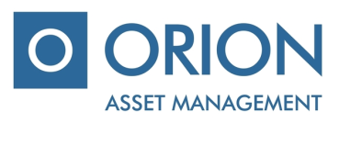

UAB “Orion Asset management”

Private limited company, registered office A. Tumėno g. 4, B corps, 11 floor, Vilnius, mob.: + 370 5 231 3833, faks.: +370 5 231 3840, email.: oam@orion.lt

IKKB “OMX Baltic Benchmark Fund” (hereinafter – “the Company”), voting ballot of the additional shareholders extraordinary meeting, which will take place on 22 June, 2018

Shareholders name, surname ………………..…………………....................…….....................................................................…

Shareholders identification number………………………………………....................................................................................

Number of shares……….....................................................................................................................................................................

Agenda of the meeting | - Approval of the Company's financial statements for 2017

VOTE

ISSUES OF THE AGENDA | DECISION | Include „for“ / „against“
Approval of the Company's financial statements for 2017 | - To approve the Company's financial statements for 2017.

Attachments:
- Project of Company‘s Articles of Association.

________________________________________________
(Shareholders (representative) name, surname, signature)

